# Customer User Guide – Wynne’s Tours

**Getting Started**

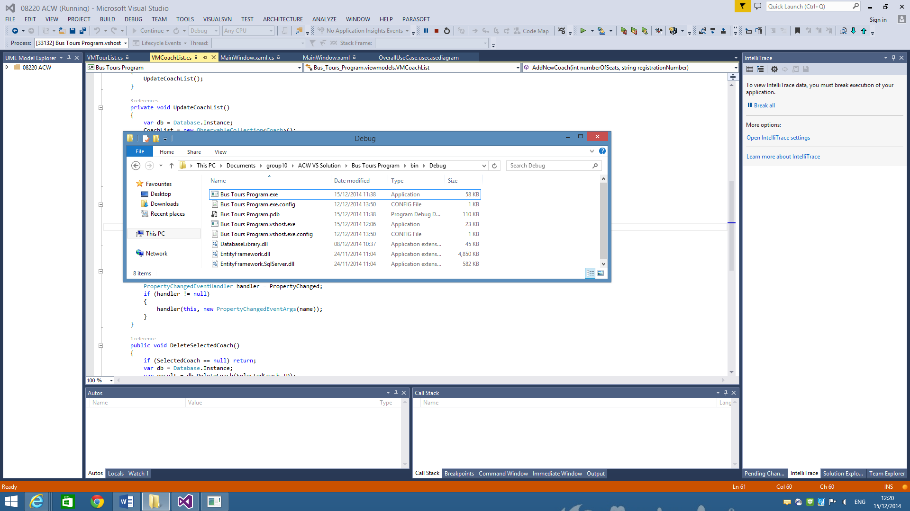

To start up the software, first open up the tool bar and start the executable ‘Bus Tours Program.exe’. Or if provided, use the shortcut created by the installer. This will open up the program and bring user to the main window which looks like this:

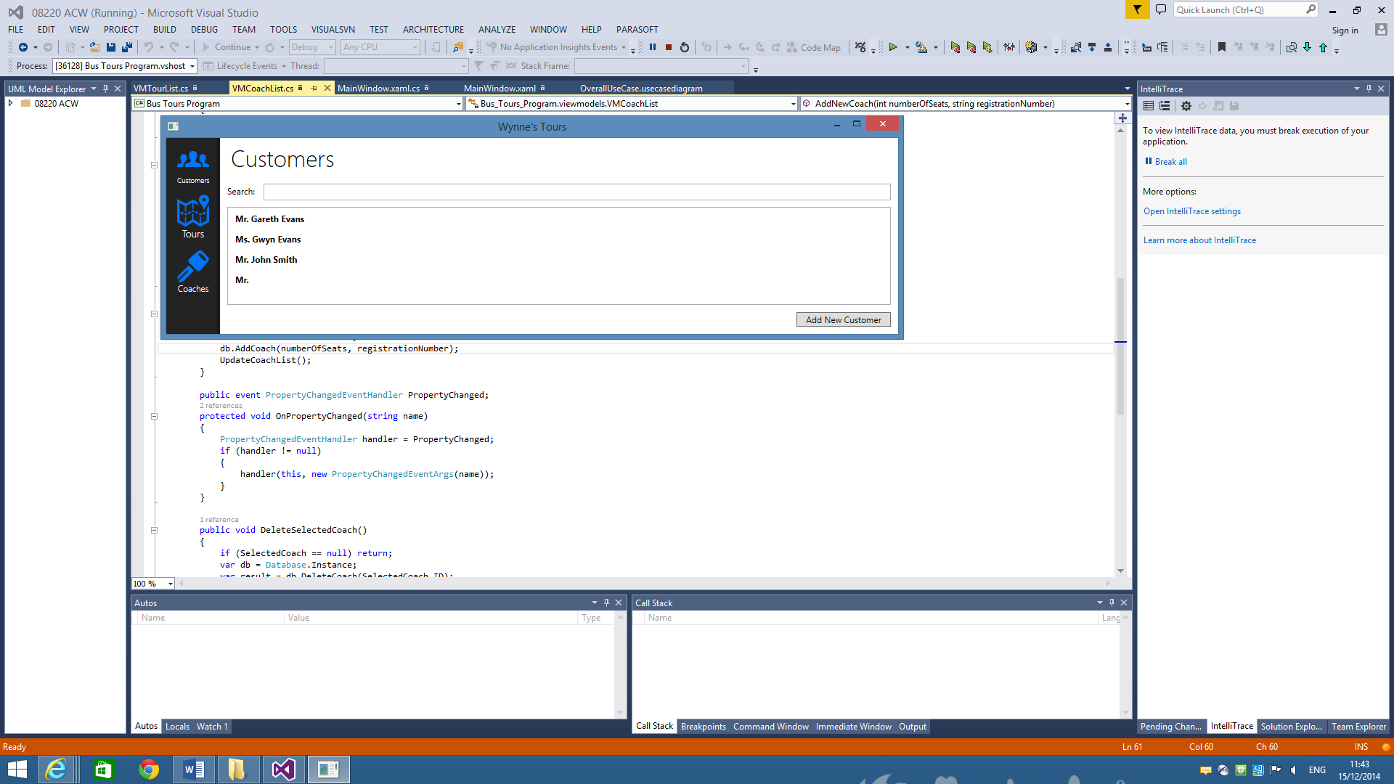

**Customers Window**

On the left hand side the user will have a range of different views to select from. The initial option selected is the ‘Customers’, this gives the customer representative the option to search the database for existing customers or add an additional customer to the list. Following this the user can select an existing customer on the list and have a range of options for that customer which include delete customer, upgrade to gold, book tickets and cancel ticket.

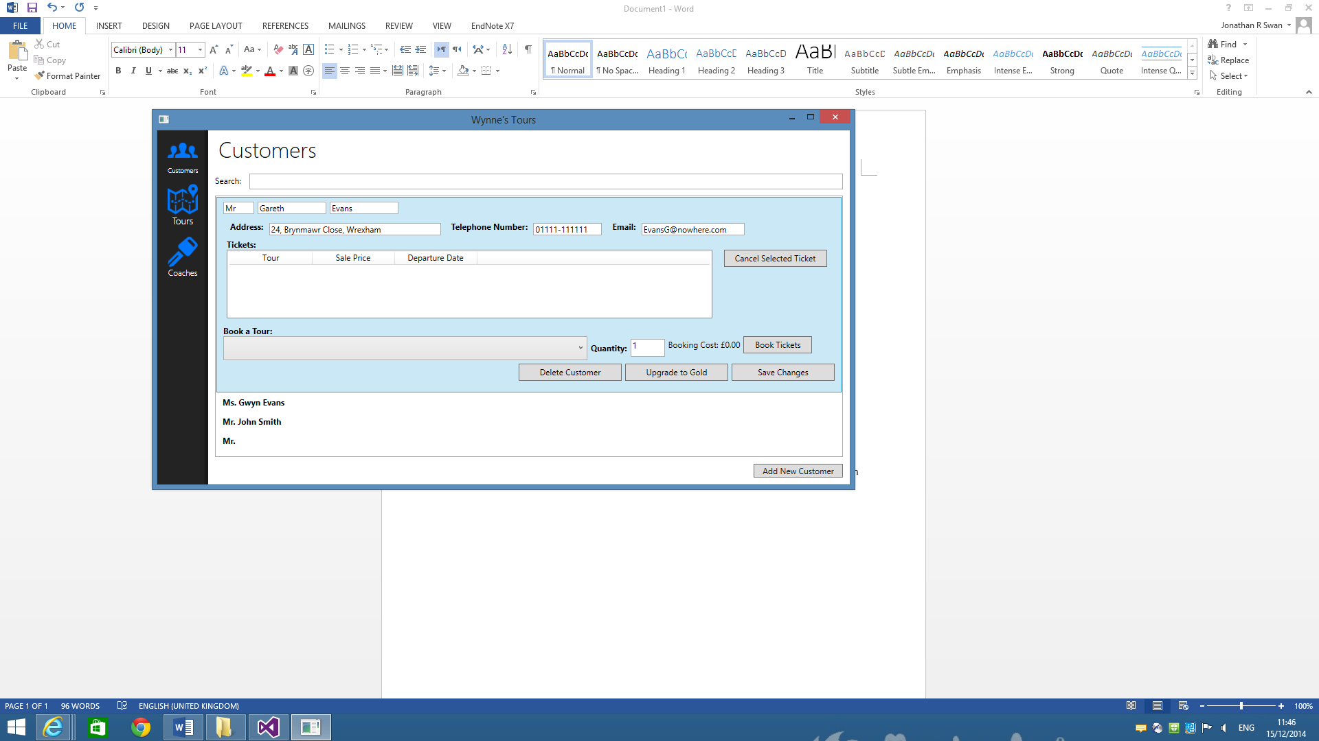

To book a ticket for a customer, select a tour from the dropdown in the “Book a Tour” section, enter a quantity of tickets to be purchased. The subtotal of the selected tickets will then displayed and payment should be taken from the customer. Click “Book Tickets” to finalise the transaction.

**Tours Window**

In addition to the ‘customers’ page (designed for interaction with the customer representative), there are additional pages for various other positions in the company. The tours window is designed for the manager and will allow them to view, edit and delete any selected tour. Not only does this window show the name of each trip, it also shows details on the date, coach, number of seats and much more. This makes using the software easy as it does not require the user to skip through multiple windows to get the information they need. The tours window can also be used by the coach driver to see all available seats on the coach and which ones are sold.

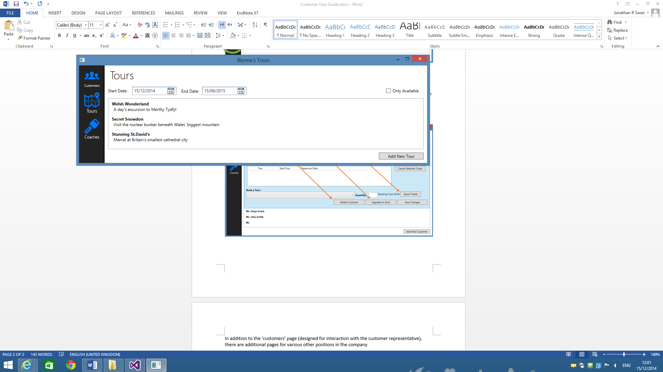

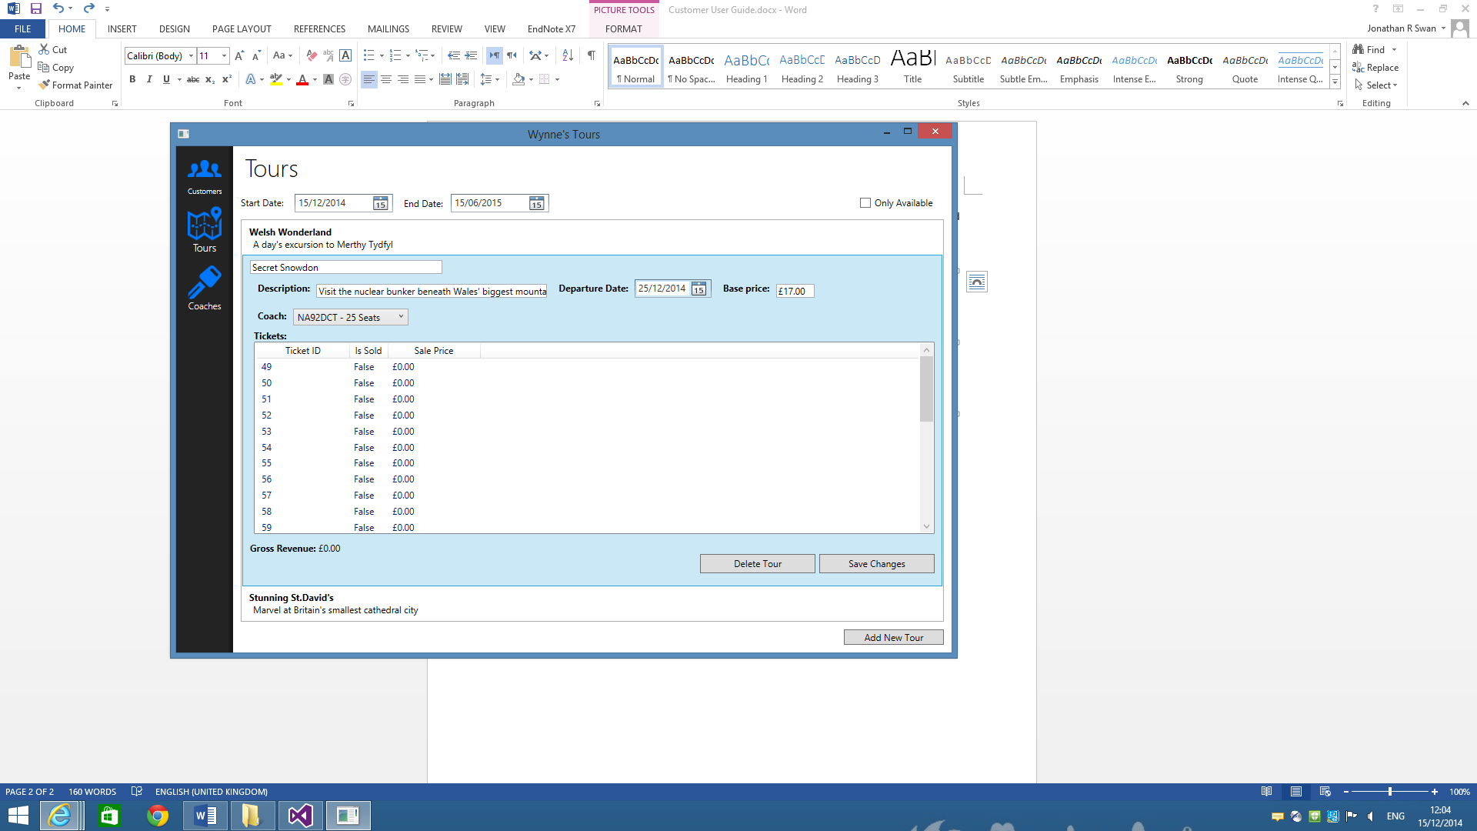

**Coaches**

The ‘coaches’ window shows all the current coaches that the company maintains. If the company decides to expand, coaches can easily be added to the system by entering the various details then pressing ‘Add Coach’, alternatively the coaches can be deleted by pressing the ‘Delete Selected Coach’ button.

